MILESTONE 10 :Web integration
Publishing helps us to track and monitor key performance metrics, to communicate results and progress. help a publisher stay informed, make better decisions, and communicate their performance to others. Publishing dashboard and reports to tableau public

Go to Dashboard/story, click on share button on the top ribbon
Note: This process is also explained in the flask part mentioned below
Give the server address of your tableau public account and click on connect.
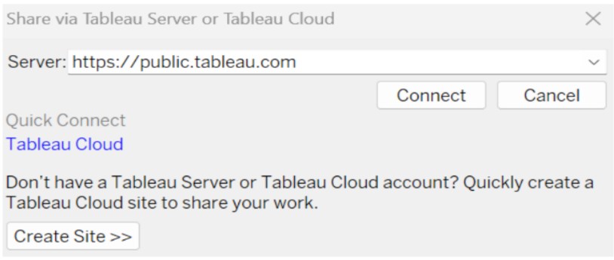
Step 2: Once you click on connect it will ask you for tableau public user name and password.
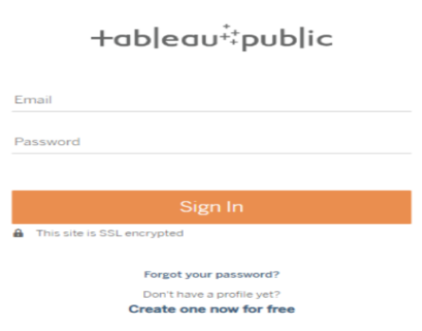
Once you login into your tableau public using the credentials, the particular visualization will be published into tableau public.
Note: While publishing the visualization to the public, the respective sheet will get published when you click on share option.

Dashboard and Story embed with UI With Flask
Explanation video link:TableauFlask.mp4
